EMBA Machinery is leading supplier to the corrugated converting industry. EMBA machines are well established for their premium print qualities, fast set up times and unique vacuum transport. Through continues R & D and after-sales support EMBA deliver reliable, high-quality solutions for their customers.
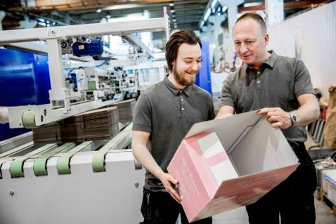

EMBA QS ULTIMA™
Based on the patented UltimaTM platform, EMBA machines combine outstanding productivity, flexibility and material efficiency. The non-crush technology preserves the geometry and strength of the corrugated profile for optimum box performance and significant savings in material costs. With an advanced digital communication and an exceptionally user-friendly operator interface, the highly automated and servo controlled EMBA QS ULTIMATM cuts setting time to a minimum. The machine is designed for maximum production output with shortest set-up time.

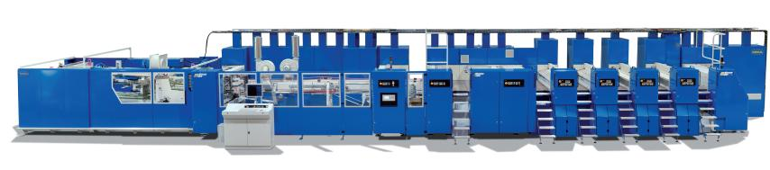

175 QS ULTIMA™
Board caliper: 1.2-8mm
Machine speed max: 500 sheets/min (30,000 sheets/hr)
Nominal print cylinder diameter: 218.3 mm (including printing plates)
Max. printing area: 600 x 1750 mm (full machine size)
Min. printing area: 200 x 400 mm
Unfolded sheets: max. width 1550 mm

215 QS ULTIMA™
Board caliper: 1.2-8mm
Machine speed max: 420 sheets/min (25,200 sheets/hr)
Nominal print cylinder diameter: 258 mm (including printing plates)
Max. printing area: 725 x 2100 mm (full machine size)
Min. printing area: 210 x 460 mm
Unfolded sheets: max. width 1600 mm

245 QS ULTIMA™
Board caliper: 1.2-8mm
Machine speed max: 330 sheets/min (19,800 sheets/hr)
Nominal print cylinder diameter: 365 mm (including printing plates)
Max. printing area: 1050 x 2450 mm (full machine size)
Min. printing area: 280 x 600 mm
Unfolded sheets: max. width 1850 mm

EMBA COMFORT
EMBA Comfort support program will make sure that your EMBA machine will perform to full capacity throughout its entire life cycle, benefiting from the latest know-how and technical innovations. Covering every aspect of customers need it will keep both machines and operators at full capacity.
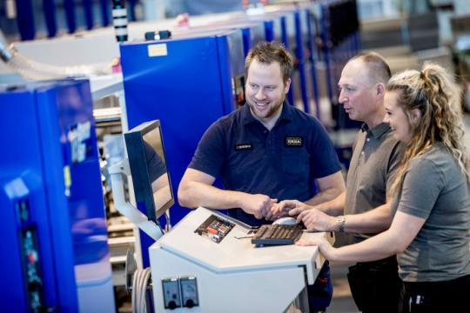
Visit EMBAs website www.emba.com

